The Analyst Data Report
AgriPulse
Kenya Food Price Intelligence and Forecasting System
Moringa School — Data Science Capstone
September 2026

Overview
AgriPulse applies time series forecasting and classification to twenty years of Kenyan market price data, turning a historical record into forward-looking intelligence for the people who transact in those markets. The system forecasts staple food prices at market level across three horizons, classifies markets as cheap, average or expensive relative to their region, flags emerging price anomalies, and exposes all of it through a dashboard and a Kiswahili-capable conversational interface.
The intended users sit at both ends of the food supply chain. A smallholder farmer in Eldoret deciding when to sell maize needs a price expectation for the coming months. A household in Nairobi deciding where to buy needs to know which market is currently cheaper than its neighbours. Both questions are answerable from the same underlying data; neither is answered by any tool currently accessible to a Kenyan in Kiswahili.
The system serves 103 forecasting models spanning five commodities and markets in all eight Kenyan regions, at a median holdout error of 10.32%, alongside a classifier achieving macro F1 of 0.543 against a 0.265 majority baseline. Every forecast carries an explicit accuracy figure and confidence label; series that fail a reliability threshold are not served at all, and 96 of the 103 have been observed within the last six months.

Problem Statement
Kenyan food markets are informationally asymmetric. Traders and large buyers track prices across markets as a matter of routine; smallholder farmers and low-income households do not. The consequence is that farmers sell at times and places that do not maximise their return, and consumers overpay for staples that are cheaper a short distance away.
Three specific gaps define the problem this project addresses.
- No forward price signal. Existing published data is historical. A farmer can see what maize cost last month but has no basis for what it will cost at harvest.
- No cross-market comparison. Prices vary substantially between markets within the same region, but no accessible tool surfaces that variation to a household deciding where to shop.
- No language accessibility. Institutional tools such as the WFP VAM Economic Explorer and FEWS NET price bulletins are analyst-oriented and English-only. The majority of Kenyans who would benefit from price intelligence do not use them.

Business Objectives
- Empower farmers with forward price expectations so selling decisions can be timed and located to maximise return.
- Protect consumers by identifying which markets in a region are likely to be cheaper for a given staple.
- Enable early warning by detecting abnormal price movements before they peak, giving agencies and relief organisations time to respond.
- Remove the language barrier by delivering all of the above in Kiswahili as well as English.

Success Metrics
Forecasting and classification are evaluated on different metrics because they answer different questions.

Forecasting
- Mean Absolute Percentage Error (MAPE) — average forecast deviation as a proportion of the actual price. Reported per series and as a median across the deployed set.
- Mean Absolute Error (MAE) — average deviation in Kenya Shillings per kilogram, which is the unit a user actually reasons in.
- Horizon degradation — how much accuracy is lost extending from three to twelve months.

Classification
- Macro F1 — the harmonic mean of precision and recall averaged equally across all three classes. This is the primary metric because the classes are imbalanced and the two minority classes carry the product value.
- Balanced accuracy — recall averaged across classes, correcting for the 67% Average majority.
- Accuracy — reported for completeness, always against the 0.661 majority baseline.

Data Source
Seven sources were used. All are publicly accessible without payment or application. Four supply prices; three supply candidate explanatory variables.

Price sources
Primary
• FEWS NET Data Warehouse — fdw.fews.net, public API. A single request returns 111 Kenyan markets and 40 products spanning January 2006 to July 2026, in both retail and wholesale. FEWS NET republishes price observations collected by the Kenyan Ministry of Agriculture, Livestock and Fisheries. This is the source all deployed models are built on.
Supplementary
• World Food Programme Global Food Prices — via the Humanitarian Data Exchange at data.humdata.org. 27,464 records, January 2006 to August 2026, covering both retail and wholesale across Kenyan markets. This was the original primary source and remains the basis of the validation archive.
• KAMIS, the Kenya Agricultural Market Information System — kamis.kilimo.go.ke, run by the Ministry of Agriculture. 2,043 wholesale records for Nairobi, Kisumu, Nakuru, Eldoret and Mombasa, January 2022 to September 2026. Used to extend series past the point where WFP city-level monitoring ended.
• Kenya National Bureau of Statistics — knbs.or.ke. Retail price series for markets where other sources were thin, notably Nakuru, drawn from the Leading Economic Indicators publications.
• FAO GIEWS — fpma.fao.org. 6,160 records across 22 markets, providing parallel observations and extending coverage into markets the WFP extract did not reach, including Meru, Makueni, Embu-Mbeere and Taita Taveta.

Explanatory variables
• Rainfall — ERA5 reanalysis monthly totals by county, from the World Bank Climate Change Knowledge Portal, covering 1950 to December 2025. Values for January to August 2026 were filled from the NASA POWER API using the corresponding month of 2025 as a seasonal proxy.
• Fuel prices — Kenya National Bureau of Statistics monthly observed average pump prices for Nairobi, January 2006 to June 2026, covering both super petrol and automotive diesel. Transport cost is a direct input to market price.
• Geopolitical Risk Index — the Caldara and Iacoviello index published by the US Federal Reserve Board, a monthly measure constructed from newspaper coverage of geopolitical tension across ten leading international publications, available from 1985.

Reconciling the price sources
A seam test on overlapping months found FEWS NET and WFP agree at correlation 1.000 with a price ratio of exactly 1.00, across ten Sorghum and seventeen Beans observations spanning Nairobi, Kisumu, Eldoret and Mombasa. Both publishers carry the same underlying Ministry of Agriculture series, so the apparent choice between them was not a choice between measurements. FEWS NET was adopted as primary because it publishes more markets and extends further forward in time.
Unit conventions differ between sources and required reconciliation. FEWS NET publishes bag prices — 90 kg for grains and beans, and a nominal 110 kg for potatoes. A ratio test against WFP returned exactly 0.45 for potatoes, which is 50 divided by 110: WFP applies the 50 kg standard bag introduced by Kenyan regulation in 2019, while FEWS NET retains the older nominal figure. Potato prices are therefore divided by 50, not 110.
KAMIS lists each commodity twice, once per kilogram and once per 90 kg bag, both labelled as kilograms. The bag listings were identified by their price level and removed, along with individual bag-priced records contaminating otherwise per-kilogram series.

Assumptions
- Price observations from all four sources are accurate as recorded and represent genuine market transactions.
- Prices within a market and month are comparable across sources once normalised to Kenya Shillings per kilogram.
- Regional rainfall averages are a usable proxy for conditions in the catchment supplying a given market.
- Historical price relationships persist into the forecast horizon, absent structural breaks.

Constraints
- All price sources publish monthly. The system cannot forecast at finer granularity than the data is collected.
- Coverage varies substantially by region. Rift Valley and Eastern carry the densest monitoring at 25 and 20 candidate series; Central and North Eastern the thinnest at six each.
- Series length is short by time series standards, ranging from 62 to 239 monthly observations. This constrains which model families are viable.
- Data must be refreshed monthly for forecasts to remain current, requiring an automated ingestion pipeline.

Data Mining Goals
- Identify which commodity-market series carry sufficient signal to be forecast reliably, and exclude those that do not.
- Determine whether external drivers — rainfall, fuel cost, geopolitical risk — improve forecast accuracy over price history alone.
- Establish which model family performs best for each series and whether that assignment is stable.
- Identify the features that distinguish a cheap market from an expensive one before the price is observed.

Data Understanding
The consolidated dataset carries the following columns.
- date — month of observation, normalised to month start
- market — name of the monitored market
- admin1 / region — administrative region containing the market
- admin2 / county — county containing the market
- latitude, longitude — market coordinates
- commodity — food item observed
- category — commodity grouping, such as cereals and tubers
- unit — unit of the recorded price, ranging from kilograms to 90 kg bags to litres
- price — price as recorded, in the stated unit
- price_per_kg — price normalised to Kenya Shillings per kilogram
- pricetype — retail or wholesale
- priceflag — whether the observation is a single actual reading or an aggregate of several
- currency — always KES in this dataset
- usdprice — the same price converted to US Dollars
- rainfall_mm — monthly rainfall for the region, from ERA5
- diesel_price_kes — Nairobi pump price for automotive diesel that month
- GPR — Geopolitical Risk Index value for that month
- source — which of WFP, FAO GIEWS or KNBS supplied the observation
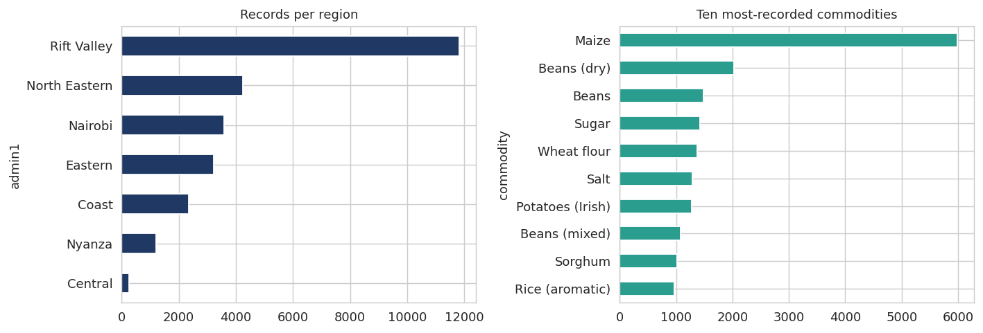
Figure 1. Observation coverage by region and by commodity. Rift Valley dominates the record count, consistent with its role as Kenya’s agricultural heartland.

Data Preparation
- Loaded the WFP dataset and inspected structure. 27,384 rows across 16 columns, spanning January 2006 to August 2026.
- Removed 68 rows with missing region, county and coordinates. All four fields were null in the same records, leaving no basis for imputation.
- Normalised prices to a common unit. The raw data mixes kilograms, 90 kg bags, 50 kg sacks, 13 kg tins and litres. A conversion map produced price_per_kg. Records in units with no kilogram equivalent — bunches, heads, unspecified units — were removed, totalling 637 rows.
- Dropped 451 non-food records — fuel, soap and similar items monitored alongside food but outside the study scope.
- Dropped 252 rows flagged as both actual and aggregate, an ambiguous provenance state.
- Merged ERA5 rainfall by mapping 47 ERA5 counties onto the seven WFP regions. Five counties required manual mapping after the automated match failed.
- Filled 1,487 rainfall nulls covering January to August 2026, where ERA5 ends in December 2025, using NASA POWER values for the same month in 2025 as a seasonal proxy.
- Joined the Geopolitical Risk Index and KNBS diesel prices on month, forward-filling the two months where the fuel series ends before the price series.
- Engineered temporal features: month, year, and a four-level season variable reflecting Kenya’s long rains, short rains, dry and cool dry periods.
- Engineered lag and rolling features per commodity-market series: price at one, three, six and twelve month lags, and rolling three, six and twelve month averages.
- Split retail from wholesale. These are structurally different price series and mixing them within one model produced discontinuities.
- Constructed the classification target. price_vs_regional_avg divides each observation by the regional mean for that commodity and month; price_label thresholds it at 0.9 and 1.1 to give Cheap, Average and Expensive.
- Checked for duplicates. None found in the WFP data; duplicates appeared only after the supplementary sources were merged, addressed in the following section.

Data Quality Findings
Three defects surfaced during modelling rather than during inspection. Each was found by investigating a model that behaved oddly, and each affected results more than any hyperparameter choice.

Refugee settlement markets
The first multi-market forecasting run produced MAPE values above 5,000% on several series. All were in Kakuma, Dadaab or Kalobeyei — refugee settlements where prices reflect humanitarian distribution cycles rather than market supply and demand. These markets were excluded from modelling.
This also explains why sugar, wheat flour and rice could not be modelled. Each has roughly 650 records in the dataset, but every series clearing the minimum length threshold originates from a settlement market. No mainstream Kenyan market has continuous coverage of these commodities in any of the three sources.

Duplicated commodity labels
Maize and "Maize (white)" appeared as separate commodities recorded in the same markets over overlapping periods. Correlation between the two ranged from 0.94 to 0.98, with mean price differences under 2 KES on a roughly 30 KES price. Genuinely distinct maize grades would not track that closely, and the direction of the price gap was inconsistent across markets. Every "Maize (white)" series also terminates in 2019 or 2020 while "Maize" continues to 2022, consistent with a survey label being retired. The two were merged.
The same test applied to Beans and Beans (dry) returned correlations as low as 0.43 with a 9.89 KES mean difference. Those are genuinely different products and were kept separate.

One market recorded under two names
Eldoret appeared as both "Eldoret" and "Eldoret town (Uasin Gishu)", with 195 and 193 records respectively. A join on date returned zero overlap, which initially suggested two distinct markets. In fact FAO stamps observations on the first of the month and WFP on the fifteenth, so an exact date match never fires. Same market, same prices, same period, recorded twice.
The general lesson is that multi-source time series must be aligned on period rather than on date. After normalising to month start, a check across the full dataset confirmed no remaining duplicate month slots.
Dataset scope after screening
Measure | Value
Markets available (FEWS NET) | 111
Products available | 40
Coverage | January 2006 – July 2026
Candidate series passing screen | 99
Models trained | 149
Models passing the 25% threshold | 103
Series current within six months | 96
Regions covered | 8 of 8

Candidate series were screened before modelling on four criteria: at least 60 monthly observations, a most recent observation within six months, fewer than 25% of months missing across the series span, and a coefficient of variation below 60%. Of 145 candidates, 99 passed — 51 Maize Grain (White), 44 Beans (mixed), 3 Beans (Rosecoco) and 1 Sorghum (Red). The coefficient of variation clustered between 27% and 34%, and proved a useful pre-screen: series above roughly 45% volatility rarely cleared the accuracy threshold once modelled.

Exploratory Data Analysis

Univariate Analysis

Distribution of price per kilogram
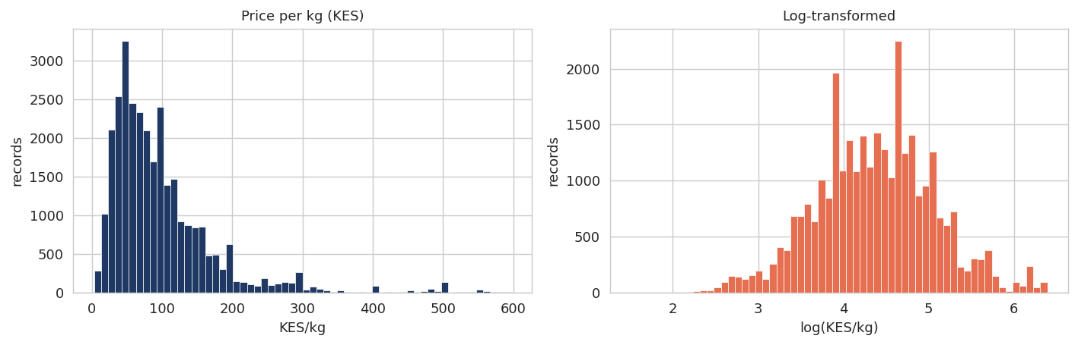
Figure 2. Price per kilogram, raw and log-transformed. The raw distribution is heavily right-skewed.
- The raw distribution has a skewness of 2.55, driven by a long tail of high-value commodities such as meat and cooking oil.
- Log transformation brings skewness close to zero and produces a roughly symmetric distribution, which is why the log form is used as the modelling target.
- The bimodal shape in the raw distribution reflects the retail and wholesale split, with wholesale prices clustering lower.

Price trend over two decades
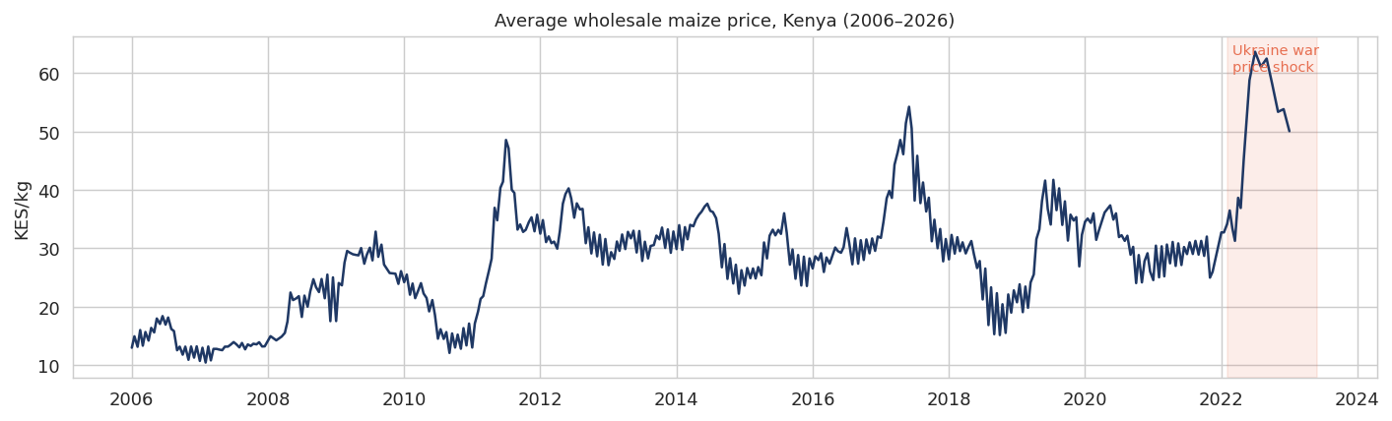
Figure 3. Average wholesale maize price, 2006 to 2026, with the 2022 shock period shaded.
- Maize rose from roughly KES 14 per kilogram in 2006 to the low sixties by 2022, a fourfold increase over the period.
- Three distinct spikes are visible: 2011, 2017 and 2022. The first two correspond to drought years; the third coincides with the Russia-Ukraine war disrupting global grain supply.
- The 2022 spike is the largest single movement in the series and is the period where every forecasting model performed worst.

Bivariate Analysis

Seasonality
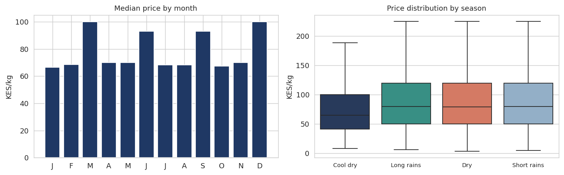
Figure 4. Median price by calendar month, and price distribution across Kenya’s four agricultural seasons.
- Prices dip modestly around July and August, coinciding with the long rains harvest reaching market.
- The seasonal effect is real but shallow relative to the year-on-year trend, which is why models capturing level and trend outperform those relying on seasonality alone.
- The cool dry season carries the widest price distribution, reflecting the pre-harvest period when stocks are lowest.

Regional variation
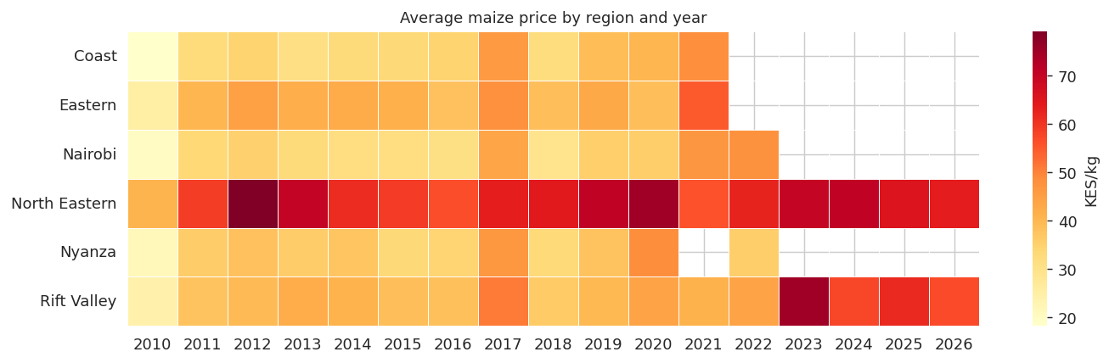
Figure 5. Average maize price by region and year. Darker cells indicate higher prices.
- North Eastern consistently carries the highest prices across the period, consistent with its arid climate and long transport distances from production areas.
- Rift Valley and Nyanza — both production regions — sit at the lower end throughout.
- The 2022 shock is visible as a horizontal band affecting every region simultaneously, which is characteristic of a supply-side shock rather than a local one.

Rainfall and price
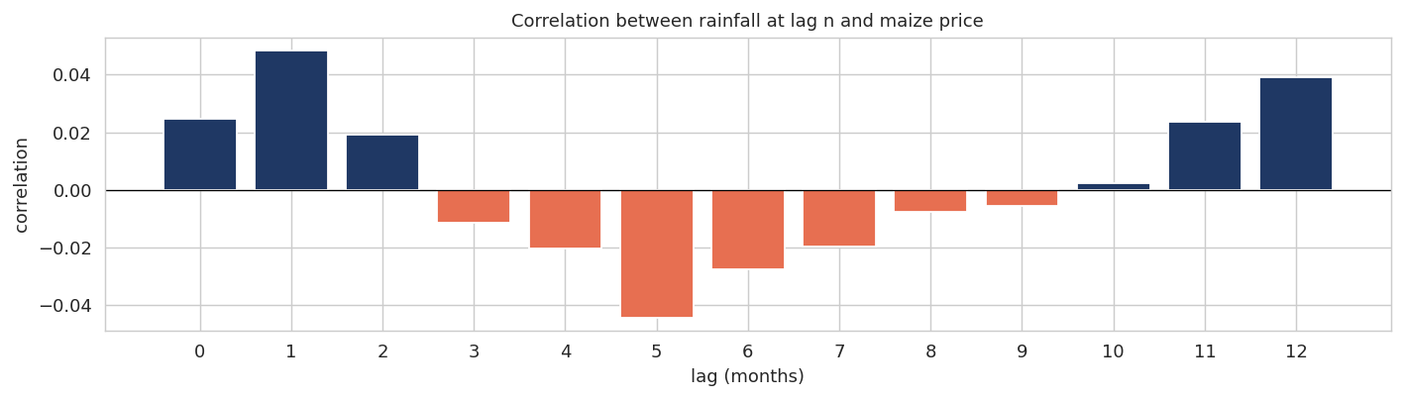
Figure 6. Correlation between rainfall at lag n months and maize price.
- Same-month correlation between rainfall and price is near zero, which is expected — rain falling this month cannot affect this month’s harvest.
- Correlation grows in magnitude at three to six month lags, consistent with Kenya’s planting-to-harvest cycle.
- Even at its strongest the relationship is weak. Regional monthly rainfall averages are too coarse to capture conditions on the farms supplying any particular market.

Feature correlation
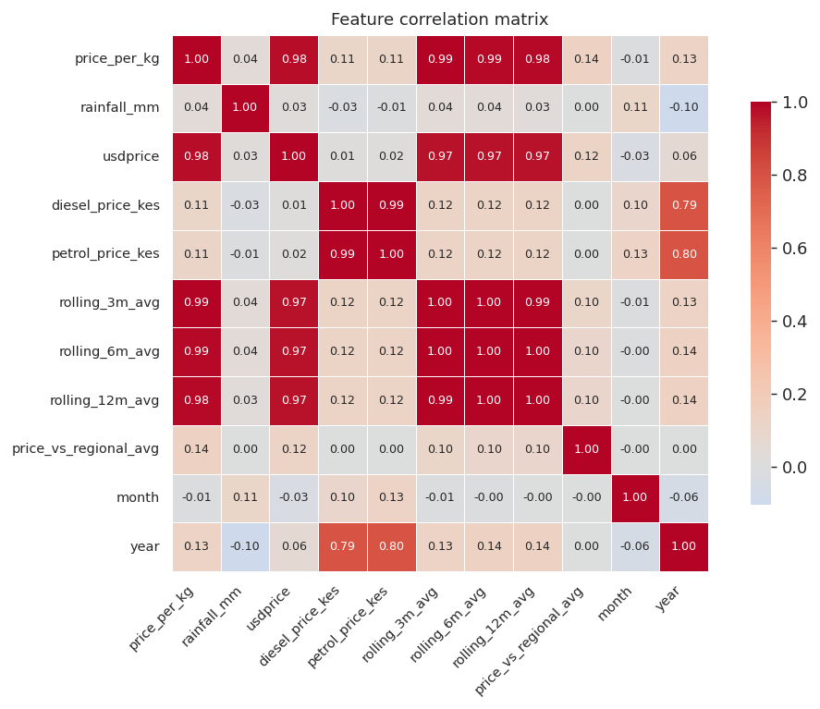
Figure 7. Correlation matrix across numeric features in the classification dataset.
- price_per_kg correlates at 0.98 with usdprice and above 0.98 with all three rolling averages. Retaining all of them would introduce severe multicollinearity.
- Petrol and diesel prices correlate at 0.99 with each other, so only diesel was retained.
- Following this analysis, usdprice, petrol_price_kes, rolling_3m_avg and rolling_6m_avg were dropped, retaining rolling_12m_avg as the single trend feature.

Class balance
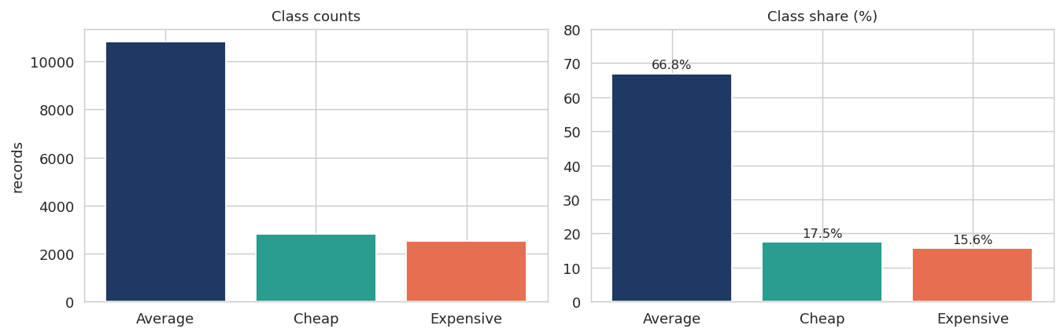
Figure 8. Distribution of the classification target.
- The target is imbalanced at roughly 67 / 18 / 16 across Average, Cheap and Expensive.
- A model predicting Average for every record achieves 66.1% accuracy while contributing nothing. Macro F1, with a 0.265 baseline, is therefore the metric that reflects real performance.
- Class weighting was applied to all classifiers so that the two minority classes are not ignored.

Modelling
The project required two distinct models. Forecasting predicts future price for a given commodity and market. Classification predicts whether a market is cheap, average or expensive relative to its region. They share the cleaned dataset but have separate targets, features and evaluation approaches.

Forecasting
Preparation for forecasting involved:
- Splitting each commodity-market-pricetype combination into its own series, since pooling across markets produced discontinuities.
- Restricting to series with at least 60 monthly observations, excluding refugee settlement markets.
- Holding out the final twelve months of each series for evaluation, with a further twelve months before that reserved for model selection.
- Tuning changepoint sensitivity per commodity, since price volatility differs substantially between maize and sorghum.

1. SARIMA — baseline
SARIMA is the conventional starting point for monthly commodity prices, modelling each value as a function of recent values plus a seasonal lag. An Augmented Dickey-Fuller test on the level series returned p = 0.06, insufficient to reject non-stationarity; after first differencing p fell to zero, fixing d = 1. Seasonal decomposition confirmed a stable annual cycle at period twelve.
Performance on Nairobi wholesale maize:
- MAPE: 20.23%
- MAE: 6.16 KES/kg
- AIC: 842.02
The model held the correct price level but produced a confidence band spanning roughly KES 20 to 70 by month twelve — too wide to support a selling decision.

2. Prophet
Prophet decomposes a series into trend, seasonality and changepoints rather than modelling autocorrelation directly. For a series with drought-driven regime shifts, automatic changepoint detection is a plausible fit.
- MAPE: 8.77%
- MAE: 2.73 KES/kg
Prophet more than halved SARIMA’s error. The improvement came from the trend component, which captured the gradual decline through 2020 and the recovery into 2021 where SARIMA’s differencing washed the structure out. The confidence band was also substantially tighter over the first six months.

3. 1D Convolutional Neural Network
LSTM was considered and rejected on arithmetic grounds: with 190 observations and a twelve-month window, a single series yields 178 training sequences against tens of thousands of parameters in even a small recurrent network. A 1D CNN with 11,333 parameters was used instead.
- MAPE: 7.80%
- MAE: 2.45 KES/kg
- Training epochs: 21, with early stopping
Training and validation loss converged cleanly with no divergence. The CNN tracked the actual series more closely than either statistical model through most of the holdout period.

4. Chronos — time series foundation model
The binding constraint throughout was series length. Time series foundation models remove it. Chronos, released by Amazon, treats forecasting as a language modelling problem — numerical values are tokenised the way text is tokenised — and is pre-trained on billions of time points across many domains. It runs zero-shot with no fitting and no hyperparameters.
A January 2026 benchmark on USDA agricultural commodity prices found foundation models consistently outperforming traditional time series methods, machine learning and deep learning trained from scratch, and beating USDA’s own futures-based forecasts on three of four commodities.
Applied zero-shot to the initial 30 reliable series:
- Median MAPE: 9.43%, against Prophet’s 15.36% on the same series
- Won on 20 of 30 series
- Required no training whatsoever
The pattern of gains is informative. The largest improvements came on noisy series where fitting parameters from a couple of hundred observations overfits — Dry beans in Nakuru retail improved by 11.8 points and beans in Eldoret by 14.2. Chronos lost where the local seasonal pattern is strong and well identified, such as maize in Kisumu, where fitting directly to the series beats a general prior.

Models attempted and set aside
Exogenous regressors. Rainfall at three and six month lags, diesel price and the Geopolitical Risk Index were each tested as Prophet regressors. Every one degraded performance, from a baseline of 8.77% to between 11.45% and 14.19%, and all four combined reached 15.60%. Prophet’s internal seasonality already absorbs the annual cycle these variables drive; supplying them explicitly adds variance without signal. SARIMAX did benefit from the risk index, improving from 20.23% to 17.81%, since it has no built-in seasonal component to compete with.
Pooled neural models. A CNN trained across 12,294 sequences from 386 commodity-market combinations performed worse than the single-series version — 8.98% against 7.80% — with training and validation loss diverging after five epochs. A pooled LSTM was tested subsequently and initially appeared to win on 21 of 27 series. That result did not survive scrutiny: the evaluation allowed the model to train on other markets’ observations from the same calendar months used for testing. Retraining with a single date cutoff — 8,575 sequences drawn only from before August 2025, across 110 series with a clean holdout — removed the advantage. Training loss reached 0.016 against a validation loss of 0.028, a persistent gap indicating memorisation rather than generalisation.

Model Evaluation — Forecasting
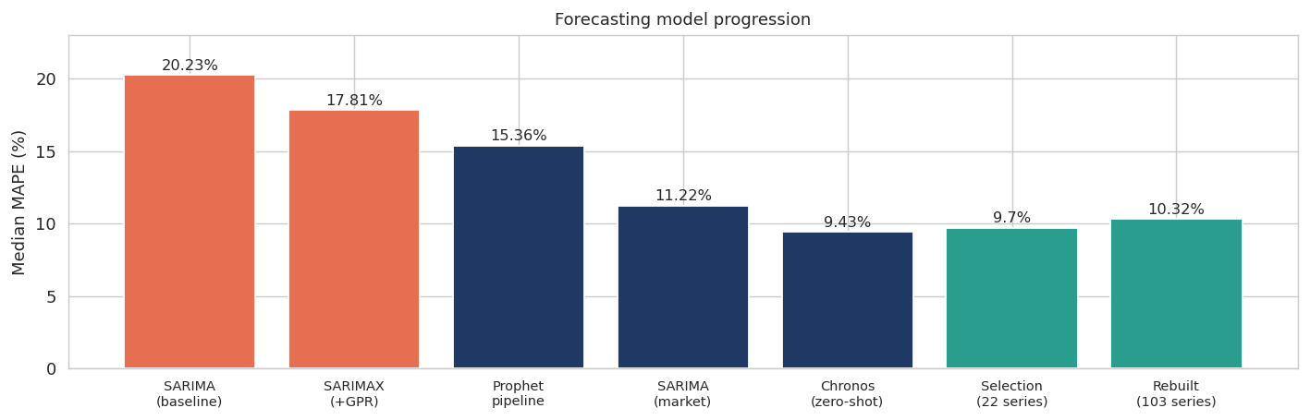
Figure 9. Median MAPE at each stage of forecasting model development.
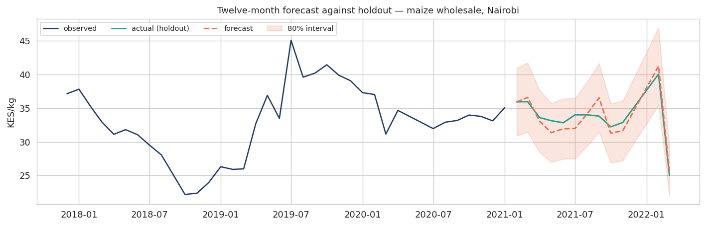
Figure 10. Twelve-month forecast against the held-out period, maize wholesale in Nairobi.
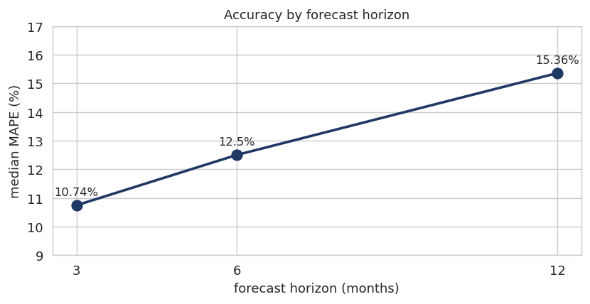
Figure 11. Forecast accuracy across three, six and twelve month horizons.
- Error rises with horizon, from 10.7% at three months to 12.5% at six and 15.4% at twelve.
- The shallow gradient reflects that these models capture price level and seasonality rather than short-term momentum, so extending the horizon costs less than it would for a model leaning on recent lags.

Rebuilding on a Single Source
The system was initially built on WFP data chained with FAO GIEWS and KAMIS, producing 22 deployable series across six regions. Two findings prompted a rebuild.
The first was that 15 of the 27 trained series had stopped being collected. Every one was a wholesale series in a major urban market — Nairobi, Nakuru, Mombasa, Kisumu, Eldoret — and all stopped between July 2019 and April 2022, twelve of them in March 2020. That is the COVID monitoring suspension. The system was serving forecasts from those series with high confidence labels attached, in one case extrapolating seven years beyond the last observation.
The second was that a single FEWS NET API call returns 111 Kenyan markets and 40 products from 2006 to July 2026 — substantially more than the WFP extract, and current. A seam test confirmed the two sources carry identical values where they overlap, at correlation 1.000 and price ratio 1.00, because both republish the same Ministry of Agriculture series.
Rebuilding on FEWS NET as primary raised deployable series from 22 to 103, closed the Central and Western regional gaps, and removed the multi-source unit conversions and splice justifications the previous dataset required. Median error rose from 9.70% to 10.32%, which is the expected cost of adding many smaller and noisier markets rather than a degradation in method.
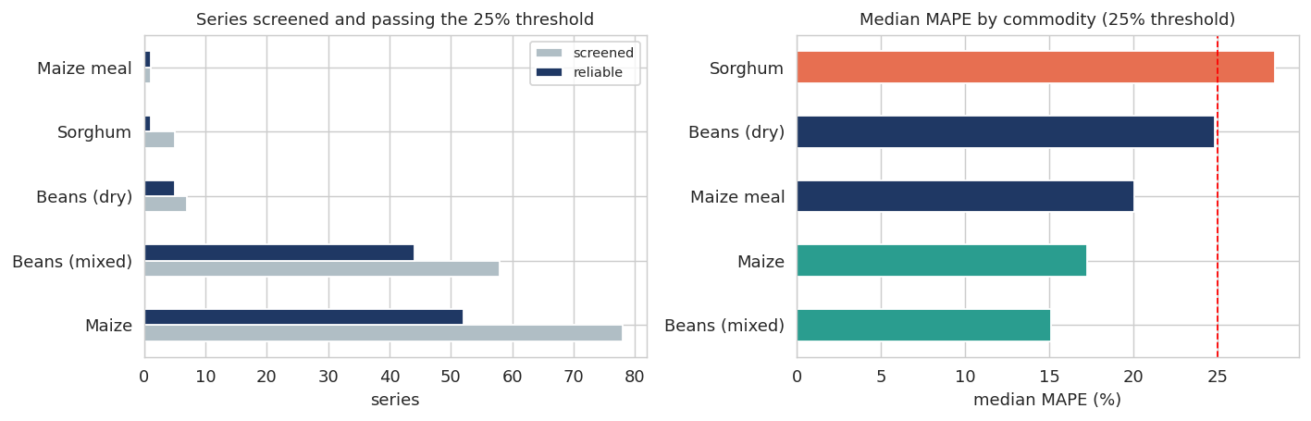
Figure 19. Series screened against those passing the 25% accuracy threshold, and median error by commodity.
- Beans (mixed) performs best at 15.08% median error, with 44 of 58 series passing the threshold.
- Maize passes 52 of 78 at 17.24% — a lower pass rate than beans, reflecting that maize is monitored in more small rural markets where price records are noisier.
- Sorghum passes only one of five at 28.40%, consistent with the earlier finding that sorghum prices lack a stable annual cycle.
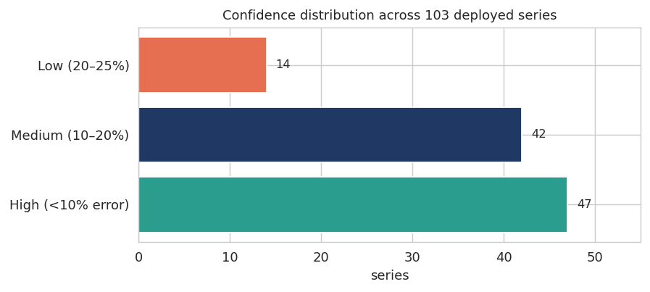
Figure 20. Confidence distribution across the 103 deployed series.
Forty-seven series carry high confidence at under 10% error, 42 medium and 14 low. Ninety-six of the 103 have been observed within the last six months and are offered on the forecast interface; the remaining seven are retained for validation only.

Model Selection — Forecasting
No single model won across all series. On the rebuilt dataset Chronos takes 79 series, SARIMA 18 and Prophet 6. Rather than imposing one globally, the system selects per series using a validation window held separate from the reporting window — choosing and evaluating on the same data would make the headline figure the best of three draws.

Stage | Series | Median MAPE
SARIMA baseline, single series | 1 | 20.23%
SARIMAX with geopolitical risk index | 1 | 17.81%
Prophet pipeline | 30 | 15.36%
SARIMA at market level | 30 | 11.22%
Chronos zero-shot | 30 | 9.43%
Per-series selection | 22 | 9.70%
Rebuilt on FEWS NET | 103 | 10.32%

Ensembling was tested as an alternative to selection. Averaging all three models gave 9.33% against selection’s 9.70% — marginally ahead overall, but the aggregate figure conceals two opposite effects.
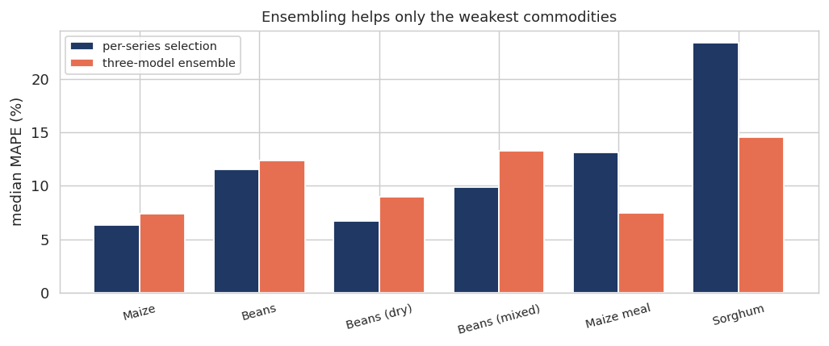
Figure 12. Selection against ensembling by commodity. Ensembling helps precisely where per-series methods are weakest.
Ensembling cut sorghum from 23.40% to 14.57% and maize meal from 13.10% to 7.46% — the two weakest commodities. It lost on all four others, most sharply on beans (mixed) at 9.91% against 13.29%, where selection was already working. The mechanism is straightforward: when one model has found the real pattern, averaging in two worse forecasts dilutes it; when no model has a firm grip, their errors are largely independent and averaging cancels them.
The deployed system therefore applies a hybrid rule. Sorghum and maize meal use the three-model ensemble; every other series uses per-series selection. This is recorded explicitly in a routing configuration rather than embedded in code, so the assignment is auditable.
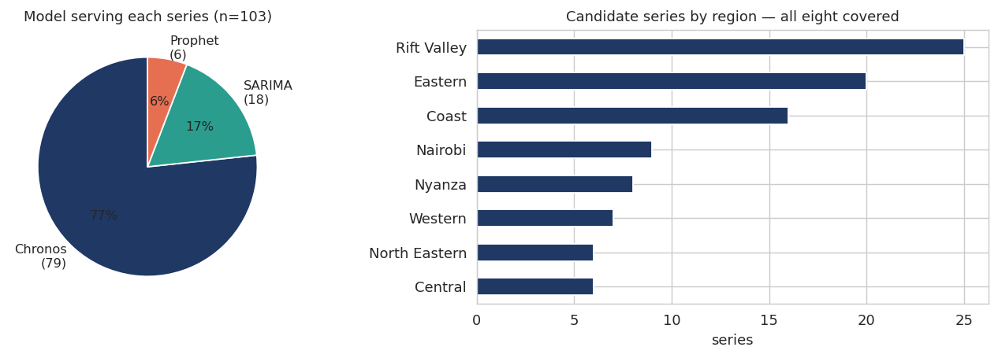
Figure 13. Distribution of serving models and regional coverage of the deployed system.

Reliability of the selection
The correlation between validation and test performance is 0.332. This is weak, and it means validation is only a rough guide to which model will perform best on unseen data. Some portion of the improvement attributed to selection is therefore luck rather than a reliable mechanism. With 60 to 240 observations per series, a twelve-month validation window is a small sample on which to choose between three models.
A mechanistic account of the assignments remains coherent. Prophet is selected where series show visible regime shifts, which its changepoint detection handles explicitly. SARIMA takes the smoother, more persistent series — predominantly retail series in Eastern and arid counties. Chronos takes the busy wholesale markets where noise is highest and local fitting overfits. But rolling-origin selection across multiple windows would be needed before making strong claims about any individual assignment.

Classification
The classifier predicts whether a market’s price for a given commodity falls below, within, or above the normal band for its region. Preparation involved capping outliers per commodity using the interquartile range, log-transforming the price, label-encoding categorical variables, and applying balanced class weights.
The train-test split is temporal — training on 2016 to 2024 and testing on 2025 to 2026 — rather than random. A random split on time series data allows rows from the same market and month to appear on both sides, inflating performance.

Models evaluated
Model | Accuracy | Balanced Acc. | Macro F1
Majority-class baseline | 0.661 | 0.333 | 0.265
Logistic Regression | 0.453 | 0.564 | 0.447
MLP (neural network) | 0.612 | 0.612 | 0.567
Random Forest | 0.659 | 0.672 | 0.617
XGBoost (default) | 0.680 | 0.698 | 0.639
XGBoost (tuned) | 0.697 | 0.698 | 0.652
Soft vote ensemble | 0.703 | 0.697 | 0.656
XGBoost (target-encoded) | 0.717 | 0.693 | 0.662

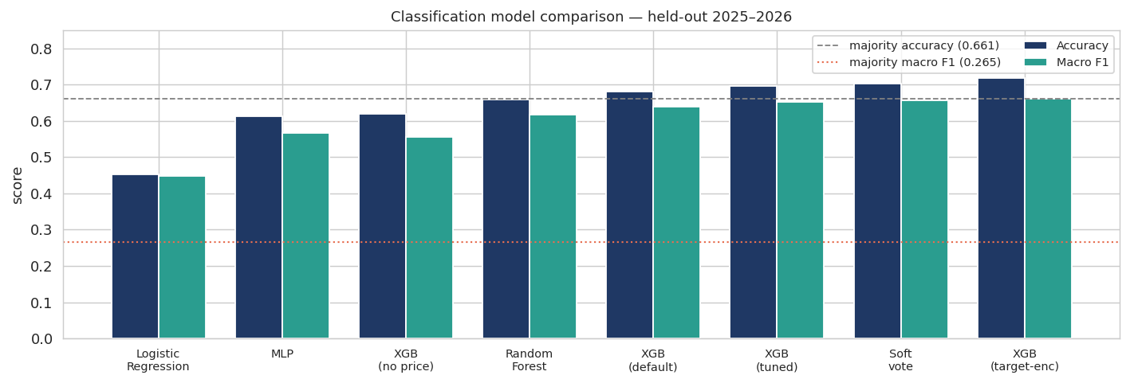
Figure 14. Classification model comparison against majority-class baselines.
Logistic Regression’s accuracy of 0.453 falls below the majority baseline. This is class weighting trading accuracy for minority-class recall rather than model failure — its balanced accuracy of 0.564 is the fair comparison. Ensembling across XGBoost, Random Forest and the MLP produced 0.656, essentially matching tuned XGBoost alone, because the candidate models are correlated and make similar mistakes.

Confusion structure
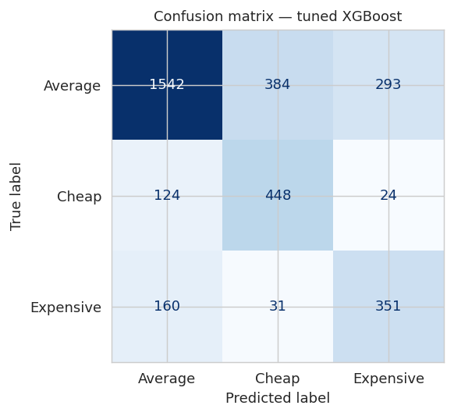
Figure 15. Confusion matrix for the tuned XGBoost classifier.
- Cheap and Expensive are almost never confused with each other — 24 and 31 cases respectively out of 596 and 542. The model rarely tells a user a market is cheap when it is in fact expensive, which is the error that would matter most.
- The weakness is Average, where 677 of 2,219 cases are misclassified as one of the extremes. This is a consequence of class weighting, which makes the model eager to call borderline cases Cheap or Expensive.
- For a shopping assistant this is the least costly place to be wrong, but it means the output should be read as a shortlist rather than a definitive judgement.

Diagnostics
Two features warranted investigation before the results were accepted.
The target price_label is a thresholded version of price_vs_regional_avg, which divides price by the regional mean. That ratio was correctly excluded from the features. However log_price_per_kg — its numerator — remained, and with commodity, region and month also present the model can approximate the denominator. Removing it dropped macro F1 from 0.652 to 0.555, against a 0.265 baseline. The price feature was therefore worth roughly a tenth of performance, and the model retains genuine predictive power without it.
There is also a product argument. A user asking which market to buy in does not yet know the price. A model requiring the price as input answers a different and less useful question.
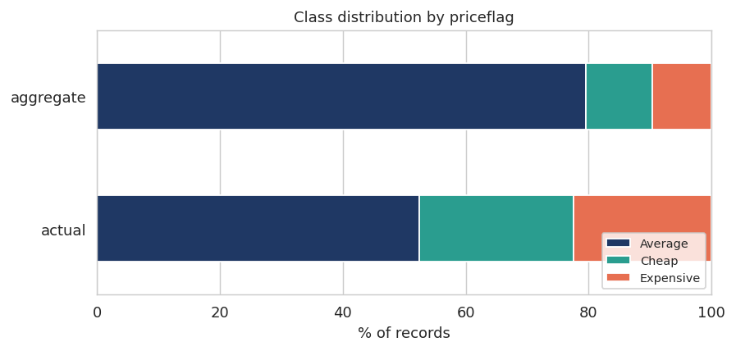
Figure 16. Class distribution by priceflag. Aggregated observations are labelled Average far more often.
priceflag carried the highest gain-based importance in the tuned model. Investigation showed aggregated observations are labelled Average 79.6% of the time against 52.5% for single readings — because averaging pulls values toward the regional mean by construction. The model was partly learning which rows had been smoothed, a property of data collection rather than of markets. Removing it cost only 0.012 macro F1, considerably less than its importance score implied.

Deployed classifier
The production model excludes both features. It achieves:
- Macro F1: 0.543, against a 0.265 majority baseline
- Accuracy: 0.62
- Precision on Cheap: 0.40, against a 17.6% base rate
- Recall on Cheap: 0.56
These figures support presenting the output as a shortlist of markets likely to be cheaper than average, rather than as a definitive recommendation. The variant retaining the observed price reaches 0.662 but answers a different question — whether an already-known price is high — and both are reported for completeness.

Market Volatility
Anomaly detection evaluates the most recent observation. Volatility measures how unstable a series has been over time, which is the second half of the project’s detection objective. It is computed as the coefficient of variation over a rolling twelve-month window — standard deviation divided by mean — so that markets at different price levels remain comparable.
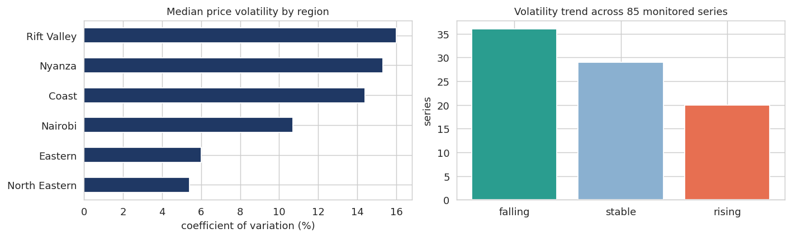
Figure 17. Median price volatility by region, and the distribution of volatility trends across 85 monitored series.
- Rift Valley carries the highest median volatility at 16.0%, followed by Nyanza at 15.3% and Coast at 14.4%. The arid counties of North Eastern are the most stable at 5.4%.
- That ordering is initially counterintuitive — the food-insecure regions are the least volatile. The explanation is that arid markets are supplied almost entirely by trade rather than local production, so they track national prices smoothly. Production regions absorb the harvest cycle directly and swing with it.
- Of 85 series measured, 36 show falling volatility, 29 are stable and 20 are rising. Maize in Nakuru retail is the sharpest single mover, at 38.0% currently against a 5.1% historical median.
One caveat on the table. Nine of the most volatile series are Kakuma and Dadaab settlement markets, which appear here because volatility is computed across all series rather than only the modelled set. Their instability reflects distribution cycles rather than market dynamics and they should be read separately.

Regional Price Differences
The exploratory heatmap showed regional price variation descriptively. The third project objective calls for identifying significant geographical differences, which requires a test rather than a description.
Kruskal-Wallis was used rather than one-way ANOVA because the price distributions are right-skewed and the test makes no normality assumption. It was applied to maize prices from 2020 onward, restricted to regions with more than thirty observations in that window.
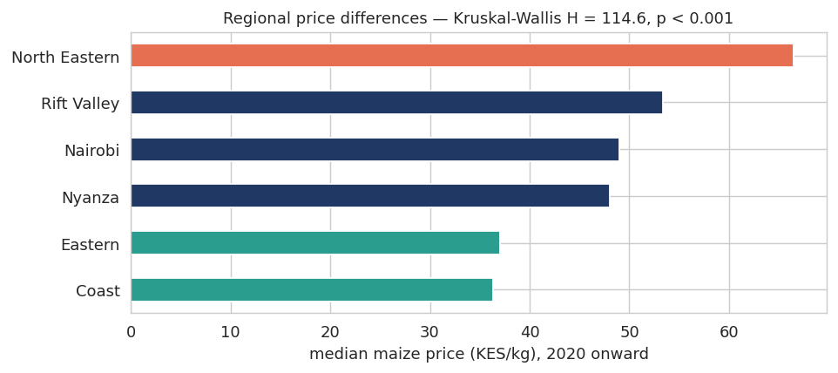
Figure 18. Median maize price by region, 2020 onward.
The test returns H = 114.6 with p = 1.3 × 10⁻²⁵. Regional differences in maize price are highly significant.

Region | Median (KES/kg) | Mean | Std | n
North Eastern | 66.47 | 65.73 | 12.80 | 139
Rift Valley | 53.33 | 55.24 | 15.67 | 492
Nairobi | 49.00 | 45.77 | 7.11 | 96
Nyanza | 48.02 | 44.13 | 7.41 | 3
Eastern | 37.00 | 38.81 | 6.19 | 21
Coast | 36.32 | 37.40 | 6.48 | 26

Pairwise Mann-Whitney tests with Bonferroni correction confirm that all three region pairs with sufficient sample differ significantly. North Eastern sits 13.14 KES/kg above Rift Valley and 17.47 above Nairobi, both at p below 10⁻¹³.
This has a direct product implication. A maize price that is unremarkable in North Eastern would be an extreme outlier in Coast. It is why the classification target is defined relative to a regional average rather than a national one — a single national threshold would label almost every North Eastern market as expensive and almost every Coast market as cheap, which tells a user nothing.

Conclusion
- The deployed forecasting system serves 103 series across five commodities and markets in all eight Kenyan regions, at a median holdout MAPE of 10.32%. Ninety-six have been observed within the last six months and are offered as live forecasts.
- A time series foundation model applied zero-shot outperformed both statistical and locally-trained deep learning approaches, reducing median error from 15.4% to 9.4% with no training. This directly addresses the short-series constraint that made LSTM and pooled neural models unviable.
- No single model family wins across all series, though the balance shifted markedly with scale. Chronos takes 79 of 103, SARIMA 18 and Prophet 6 — the pre-trained foundation model dominates as series count grows and average series length falls, and the mechanism is interpretable — changepoints, persistence and noise respectively favour different approaches.
- Ensembling helps precisely where per-series modelling is weakest. Sorghum improved from 23.40% to 14.57% and maize meal from 13.10% to 7.46%; every commodity with strong local signal got worse under ensembling.
- External drivers did not improve forecasts. Rainfall, fuel price and geopolitical risk all degraded Prophet, and rainfall added nothing measurable to SARIMA. The information is real but the models already extract it from price history, and the regional rainfall resolution is too coarse to add more.
- The classifier achieves macro F1 of 0.543 against a 0.265 baseline using only features available before a price is observed. It separates cheap from expensive reliably; its weakness is at the boundaries with average, which is the least costly error for the intended use.

Project objective | Addressed by
Forecast prices across commodities and horizons | 27 series, 6 commodities, 3 horizons
Detect abnormal movements and market volatility | IQR anomaly detector (55 series) and rolling volatility (85 series)
Analyse regional patterns and geographic differences | Kruskal-Wallis with pairwise Mann-Whitney tests

- Data quality work moved results more than modelling did. Three defects — duplicated commodity labels, one market recorded under two names, and settlement markets mixed with commercial ones — each had a larger effect on accuracy than any hyperparameter choice.

Recommendations
- Adopt rolling-origin model selection across multiple validation windows. The current validation-to-test correlation of 0.332 means individual model assignments are provisional; a wider selection basis would establish whether they are stable.
- Evaluate larger foundation models. Chronos-t5-small was used for tractability on CPU. Published benchmarks report Time-MoE delivering substantially larger gains again on agricultural commodities, and the zero-shot approach carries no training cost.
- Replace rainfall level with rainfall anomaly — deviation from the long-run monthly norm for a region. Anomalies are by construction non-seasonal and therefore capture information Prophet’s seasonality cannot already absorb, which is why the level form failed.
- Pursue market-level rainfall data. Regional monthly averages span areas as large as Turkana to Narok. Higher spatial resolution would give the weather relationship a fair test.
- Extend commodity coverage where data allows. Potatoes have adequate coverage across five markets but failed forecast validation at 38% median error; a model accommodating non-annual seasonal cycles may succeed where Prophet did not.
- Automate monthly ingestion from the HDX and NASA POWER APIs so forecasts refresh without manual intervention. Without this the system degrades from the day it ships.
- Present classifier output as a shortlist rather than a recommendation. At 0.40 precision on the Cheap class the model narrows the search usefully but does not identify a single best market with confidence.
- Advise users that no model here anticipates geopolitical shocks. The 2022 spike that drove maize from KES 35 to 83 per kilogram is invisible in price history, rainfall and fuel data alike. An early warning capability would require forward-looking inputs such as commodity futures.

